A Comprehensive Measure of Well-Being

Entity Relationship diagram

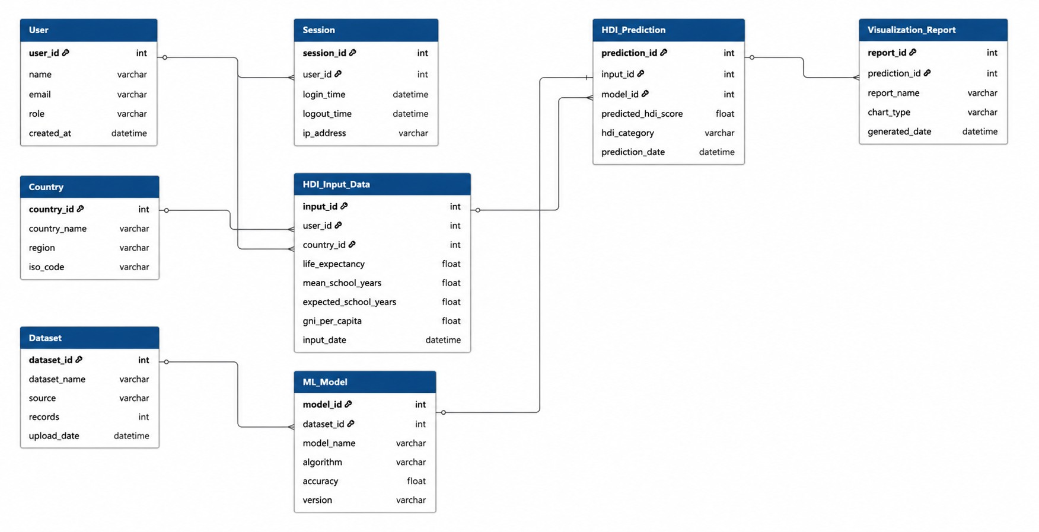
Description:
The ER diagram represents the database structure of the HDI Prediction System. It organizes user information, HDI input data, machine learning models, prediction results, datasets, reports, and sessions.
Entities: User, Country, HDI Input Data, ML Model, HDI Prediction, Dataset, Visualization Report, and Session.
Relationships:
- User → HDI Input Data (1:M)
- Country → HDI Input Data (1:M)
- HDI Input Data → HDI Prediction (1:1)
- ML Model → HDI Prediction (1:M)
- HDI Prediction → Visualization Report (1:M)
- Dataset → ML Model (1:M)
- User → Session (1:M)
This design ensures efficient data management and supports accurate HDI prediction and reporting.

